1. Explain why 𝑥(𝑡) = 𝐶𝑒 𝑗𝜔0𝑡 is always periodic with fundamental period 𝑇0 = 2𝜋/ wo . (Hint: Use Euler’s identity).

𝑥(𝑡 + T­­0) = 𝐶e 𝑗𝜔0(𝑡+T0) = Cejw0(t+2π/w­0) = C(ejw­0­t\*ejw­0­2π/w0) = C(ejw0t\*ej2π) = C(ejw0t\*1) = Cejw0t

Because the signal repeats after the interval of time T­­­0, the function is always periodic.

1. Explain why the rate of oscillation of discrete time exponential signal 𝑥[𝑛] = 𝑒 𝑗𝑤0𝑛 does not increase with 𝑤0. At what value is the rate of oscillation maximum and why?

x’[n] = ej(w0+2π)n=ejw0nej2πn=ejw0n(cos(2πn)+jsin(2πn)) = ejw0n = x[n]

Even though the frequency changed to w­0+2π, the signal x’[n]=x[n].

The value where the rate of oscillation is maximum is +π and –π because when you plug those into the equation a negative value returns. When it is negative, the sign of x[n] alternates between positive and negative.

1. Define x[n]u[n], where x[n] is a discrete time signal and u[n] is the discrete time unit step function.
$$x\left[n\right]u\left[n\right]= \left\{\begin{aligned}x\left[n\right] if n ≥0 \\ 0 if n <0\end{aligned}\right.$$

2. Is the system 𝑦[𝑛] = 2𝑥[𝑛] + 3 linear? Provide proof.

y1[n] = 2(1) + 3 = 5

y2[n] = 2(2) + 3 = 7

2(1+2) + 3 = 9

5+7=12

9 is not equal to 12

The system is NOT linear.

1. Chapter 2 Problem 35(a)… Graph the original and transformed function

$$g\left(t\right)=\left\{\begin{aligned}-2, t<-1 \\ 2t, -1<t<1 \\ 3-t^{2}, 1<t<3 \\ -6, t>3\end{aligned}\right.$$

$$-3g\left(4-t\right)vs. t$$

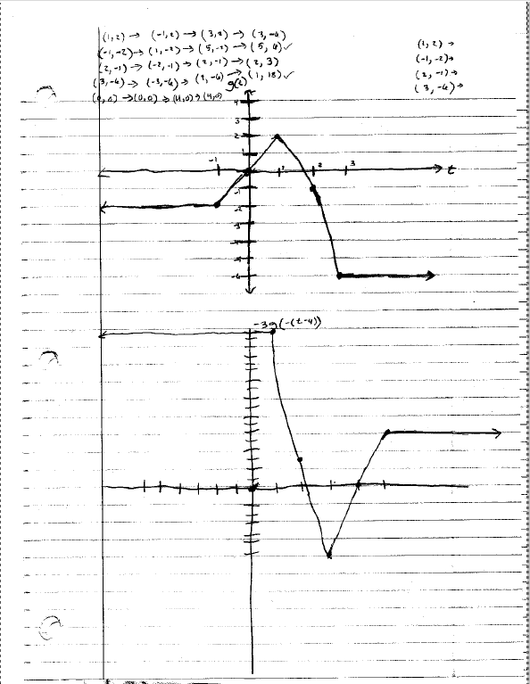

1. Chapter 2 Problem 52(h)

$g\left(t\right)=12+\sin\left(4πt\right)/4πt$

$$g_{e}\left(t\right)=\frac{12+\frac{\sin\left(4πt\right)}{4πt}+12+ \frac{\sin\left(-4πt\right)}{-4πt}}{2}=\frac{24+ \frac{\sin\left(4πt\right)}{4πt}+\frac{\sin\left(-4πt\right)}{-4πt}}{2}= \frac{24+ \frac{\sin\left(4πt\right)}{4πt}+\frac{\sin\left(4πt\right)}{4πt}}{2}= 12+ \frac{\sin\left(4πt\right)}{4πt}$$

$$g_{o}\left(t\right)= \frac{12+\frac{\sin\left(4πt\right)}{4πt}-12-\frac{\sin\left(-4πt\right)}{-4πt}}{2}= \frac{12+\frac{\sin\left(4πt\right)}{4πt}-12-\frac{\sin\left(4πt\right)}{4πt}}{2}=0$$

1. Chapter 2 Problem 57(h)

Find the signal energy of the signal.

$$x\left(t\right)=e^{\left(-1-j8π\right)t}u(t)$$

$$E= \int_{-∞}^{∞}{{\left|e^{\left(-1-j8π\right)t}u\left(t\right)\right|}^{2}dt}= \int_{0}^{∞}{{\left|e^{\left(-1-j8π\right)t}\right|}^{2}dt}= \int_{0}^{∞}{\left|e^{2\left(-1-j8π\right)t}\right|dt}= \int_{0}^{∞}{\left|e^{-2t}e^{-2tj8π}\right|dt}=\int_{0}^{∞}{e^{-2t}dt}={\left.\left[-\frac{1}{2}e^{-2t}\right]\right|}_{0}^{∞}=-\frac{1}{2}\left(e^{-∞}-e^{0}\right)=-\frac{1}{2}\left(0-1\right)=-\frac{1}{2}\left(-1\right)=\frac{1}{2}$$

1. Chapter 3 Problem 27(a)

